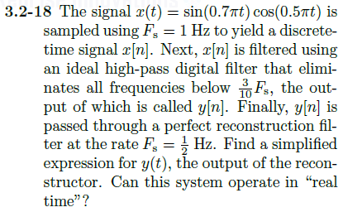

Multiplying in time 🡪 Convolution in frequency

Sinusoids with $F_{1}=0.35Hz$ and $F_{2}=0.25Hz$ will have impulses in the frequency domain at these frequencies

Multiplying these two sinusoids will lead to a $X(ω)$ of:

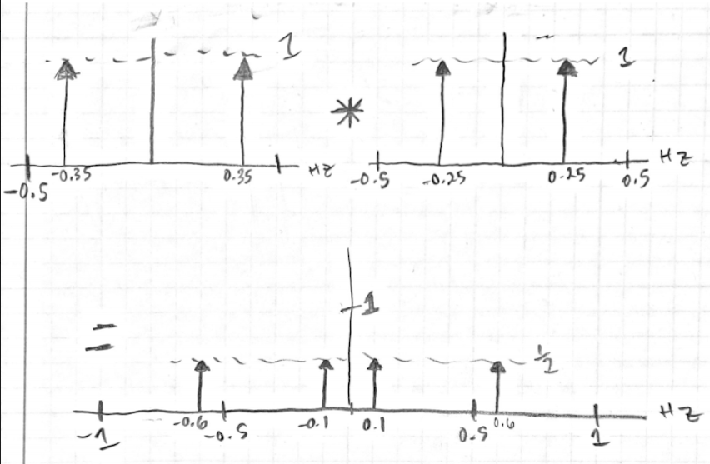

π/2

π

π

π

Sampling at $F_{s}=1Hz$ will lead to periodic replications of $X(ω)$ centered around integer multiples of 1Hz

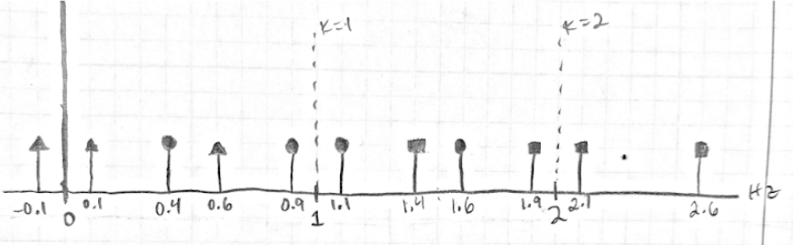

π/2

We can see that the replications do overlap into the original BW of x(t), but they do not add onto the original spectra

If an ideal LPF with $f_{0}=0.3Hz$ is applied:

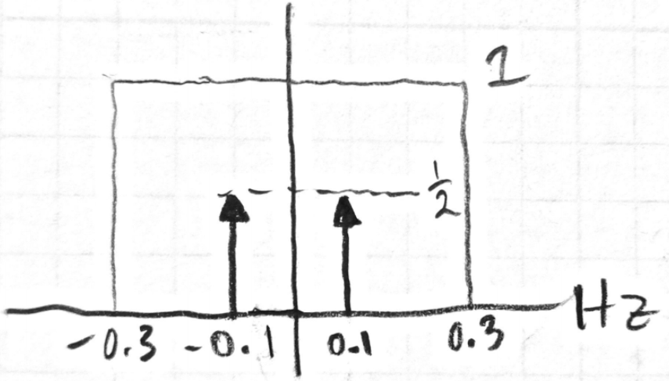

π/2

If this is passed through a perfect reconstruction filter with $F_{s}=\frac{1}{2}Hz$:

$$H_{reconstruction}\left(ω\right)=TΠ\left(\frac{ωT}{2π}\right)=2Π\left(\frac{ω}{π}\right)=2Π\left(2f\right)$$

Since $F_{s}=0.5Hz>2*0.1Hz$ this will reconstruct the signal to be:

$$y\left(t\right)=0.5cos⁡(0.2πt)$$

This could have been achieved by passing our original signal, x(t), through an ideal LPF with pass band gain of 0.5 and a cutoff frequency of 0.3Hz